|  |  |  |  |  |  |  |  |  |  |  |  |  |  |  |  |  |  |
| --- | --- | --- | --- | --- | --- | --- | --- | --- | --- | --- | --- | --- | --- | --- | --- | --- | --- |
| **Year 11 Mathematics Specialist**  **Test 3 –2015**   |  |  |  |  | | --- | --- | --- | --- | | **Total Time:** | ***55****minutes* | |  | | --- | | **/55**  **------%** | | | **Total Reading:** | *3**minutes* | | **Total Working:** | *58 minutes* | | **Weighting:** | *% of the year.* | | **Equipment:** | *SCSA Formula Sheet; ½ page notes (A4 one side), CAS*  *calculator; Scientific Calculator* | | |  | | | |  |

**1. [7 marks]**

Two tangents are drawn from point T to points A and B on a circle as shown in the diagram. Given the angle between the tangents is 440 calculate the size of  showing proof of each result.



**2. [8 marks]**

Consider point M external to the circumference of the circle centre C. A secant is drawn from M passing through the centre C also intersecting the circumference of the circle at 2 points A and B. A line is also drawn from M to the circle at a point of tangency T.





**3. [7 marks]**

A group of 67 Year 9 students responded to a survey stating they owned one or more of the following items.

A: An internet connected mobile phone

B: A tablet or iPad

C: A laptop computer

The following information was recorded using set notation

n(A) = 37, n(B) = 28 and n(C) = 32 and the following notes were made.

There were as many students who owned all three as those who owned a phone and iPad but not a laptop.

There were as many students who owned all three as those who owned a laptop and iPad but not a phone.

There were twice as many students who owned a phone and laptop but not an iPad as those who owned all three.

1. Calculate how many students owned all three devices.
2. Calculate how many students owned only one of these devices.

## **4. [5 marks]**

## In ΔABC, thepoints Mand N divide the sides AB and ACrespectively in the ratio 1 : 3. Let AB = ***u*** and AC = ***v***. Find **BC** and **MN** in terms of ***u*** and **v**, and hence prove that **BC** = 4**MN**.

## 

## **5. [4 marks]**

## State whether each of the following are true (T) or false (F):

## i. The contrapositive of a true statement is always true. _____

## ii. The converse of a true statement is always true. _____

## iii. The “equivalent” symbol used in proofs in Mathematics is ⇔ _______

## iv. The converse to the statement**, “**A triangle is a polygon.”

## is “A polygon is a triangle.” _____

**6. [12 marks: 7, 4, 1]**

Two forces act on an object in a flat plane. **F1** has a magnitude of 4 newtons and acts on a bearing of 0350 and **F2** with a magnitude of 5 newtons acts on a bearing 1130.

1. Use the triangle rule to calculate the magnitude and direction of the resultant force to an accuracy of two (2) decimal places.

1. Calculate the **i** and **j** components of **F1** and **F2** given the unit vector **i** is on a bearing 00 T and the unit vector **j** is on a bearing 900 T

1. Evaluate **F1** + **F2** in **i** and **j** component form.

**7. [3 marks]**

Use proof to show that a triangle with sides 8 cm, 15 cm and 17 cm is right angled.

**8. [5 marks]**

In Triangle ABC below, AD = 13 cm, DB = 5 cm, AE = 9 cm and DE = 5 cm.

Prove that BC = 10 cm.

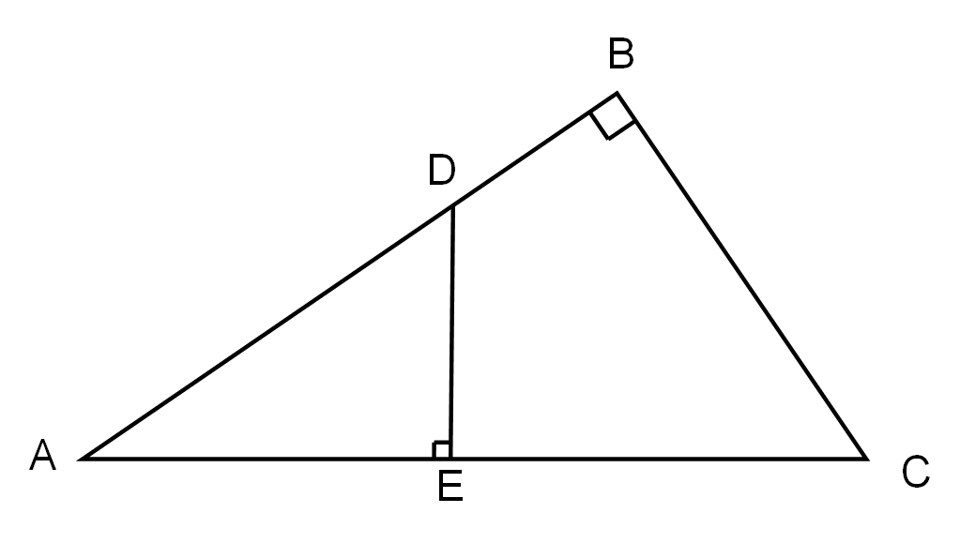

**END OF TEST**